**Operating Systems Lab**

**Spring 2025**

**Lab Task 07:**

**Stream, Redirection & Pipes**



**Lab Instructor:**

**Ayesha Akram**

**Lab Task 07**

**Student Name: Areeba Usman**

**Sapid: 49039**

**Department: BSCS-5**

**Question 01**

What would be the result of the following commands. Understand that is

* cat filename > new // filename is name of file that exist at current path
* who > new
* ls | sort –r
* ls | sort -r >> new

Also define the understanding of these commands in your own words.

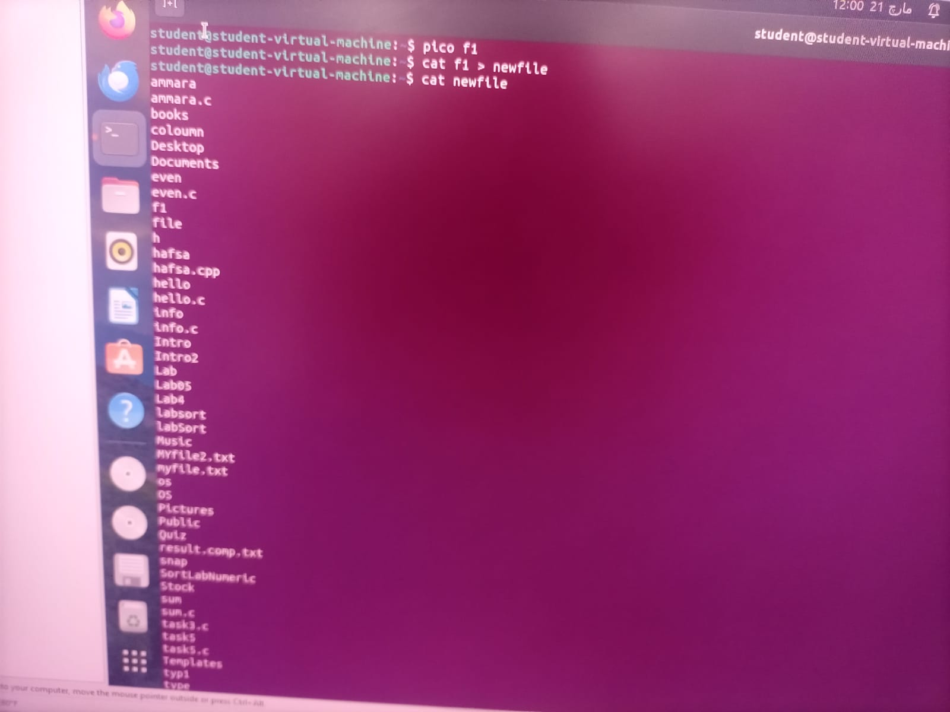

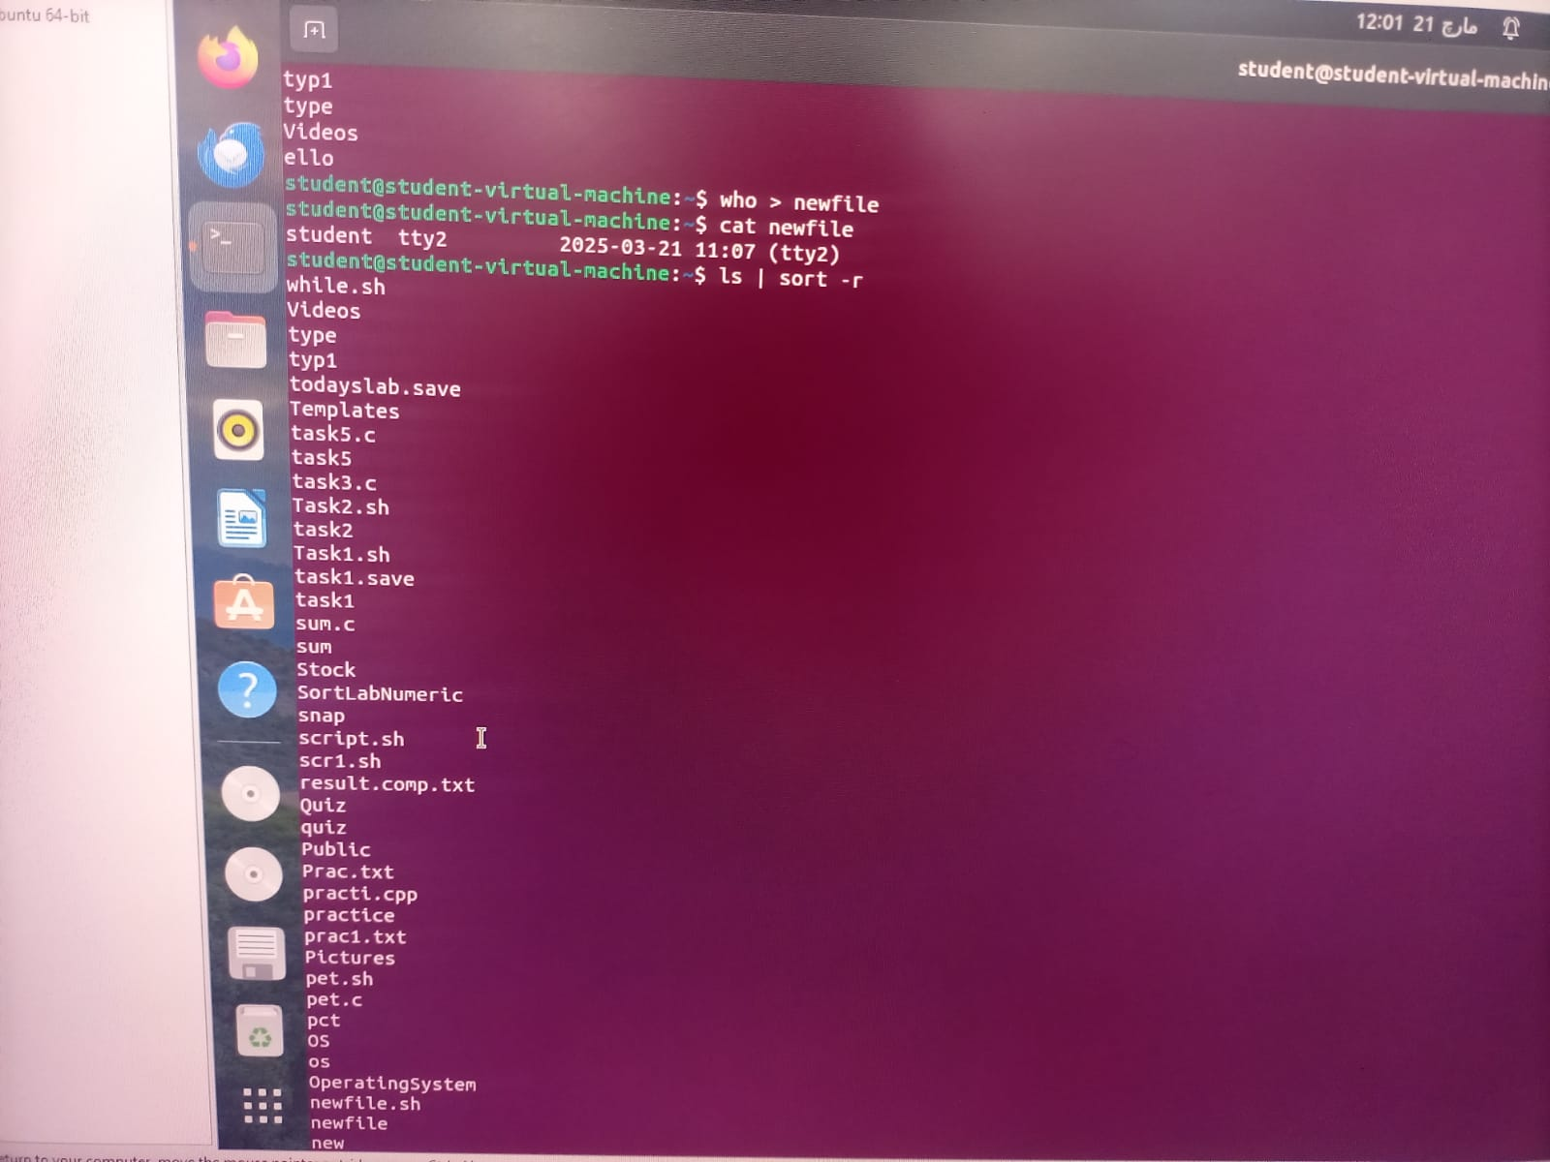

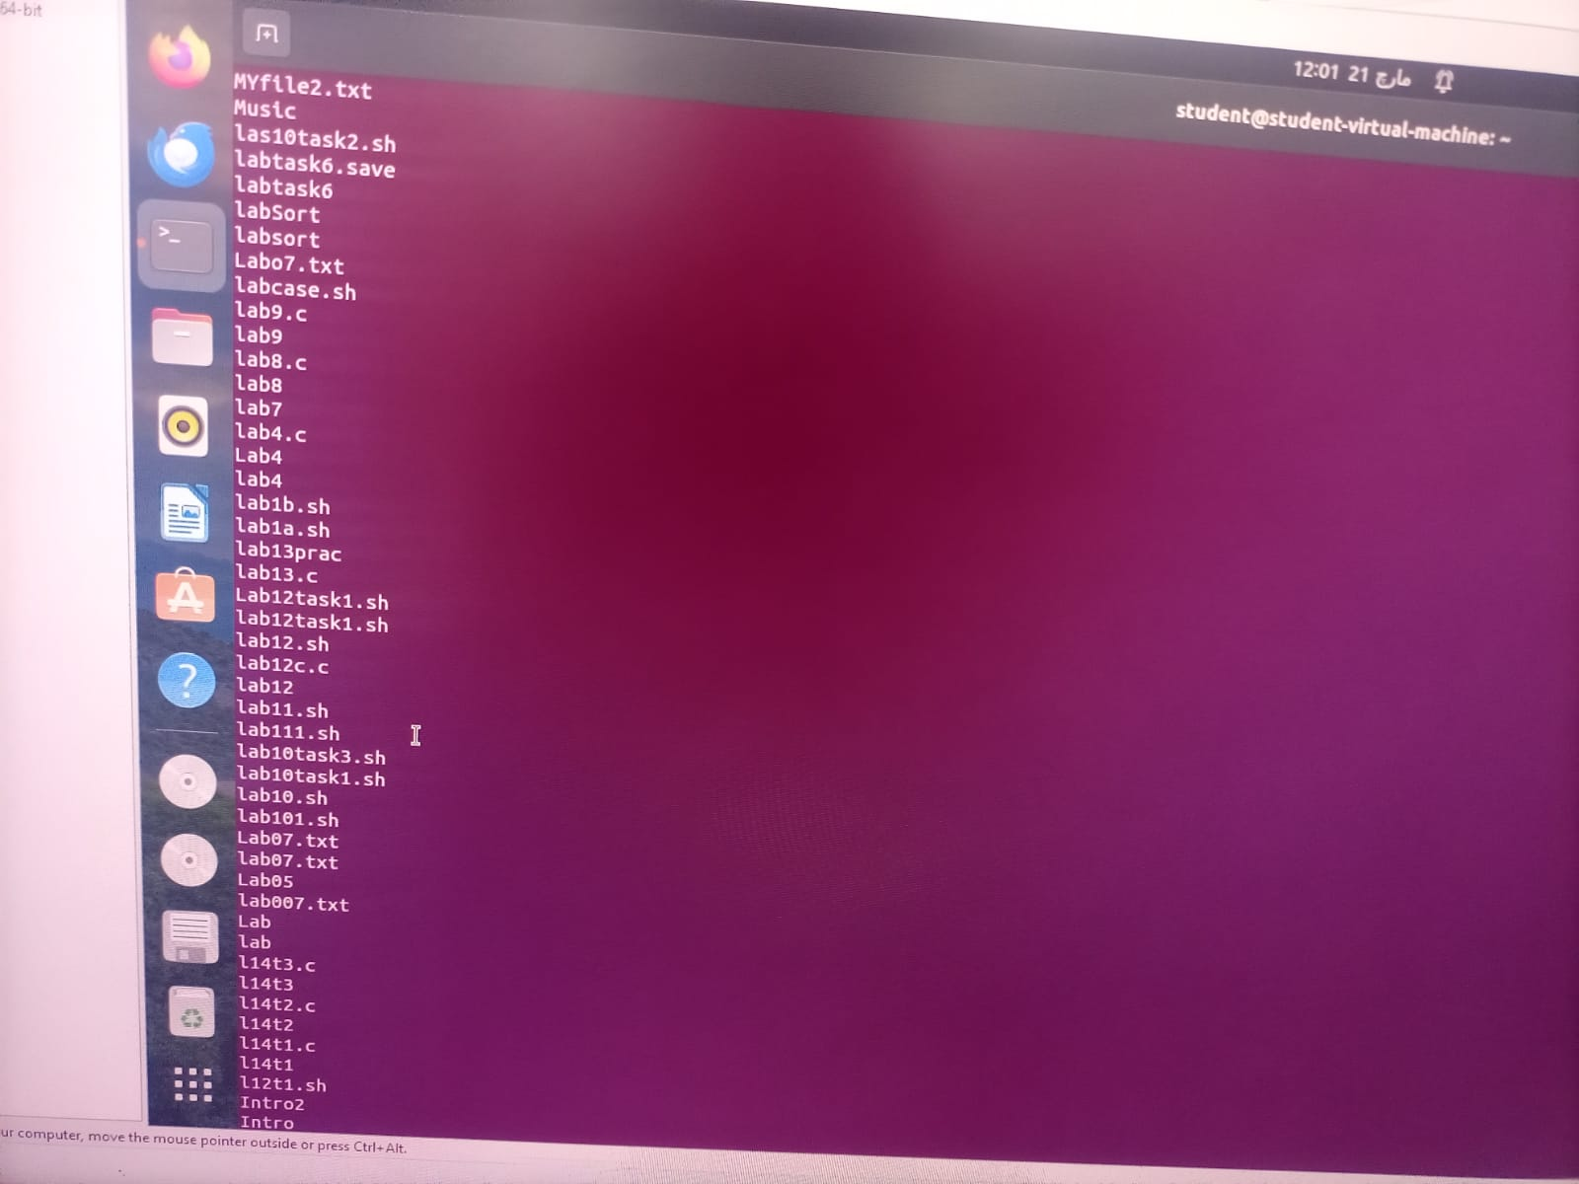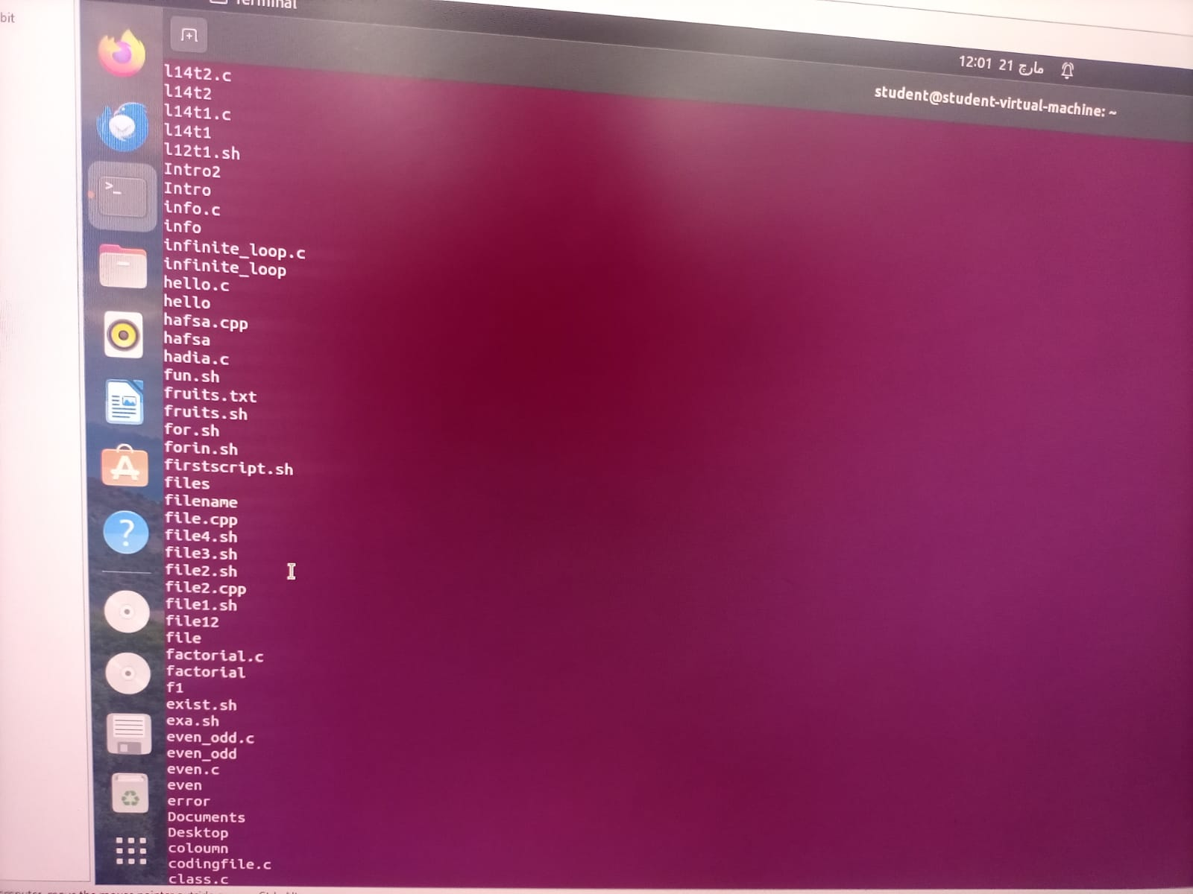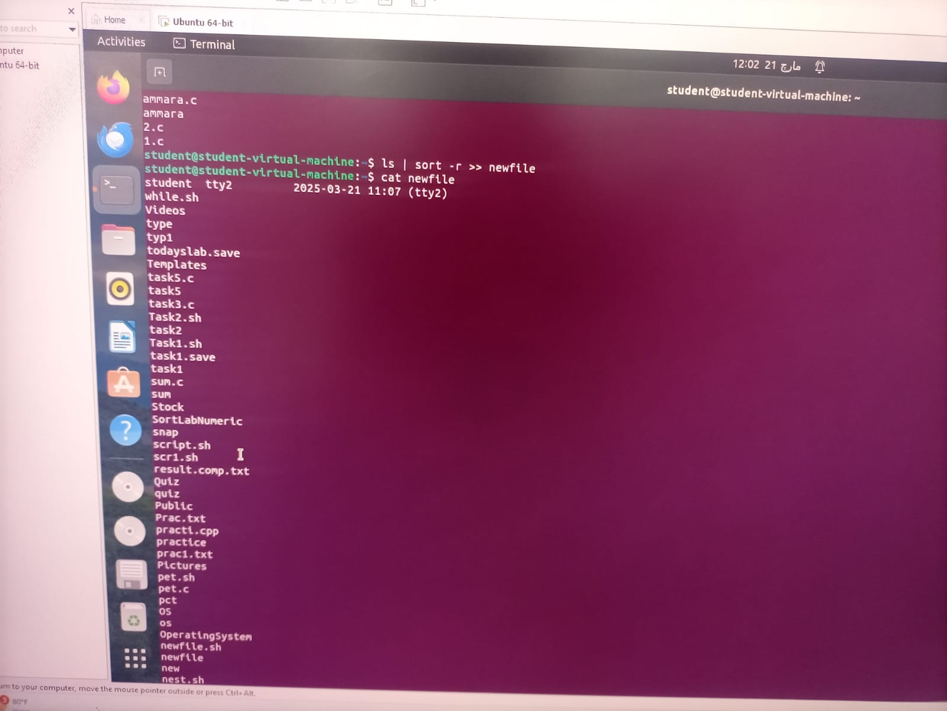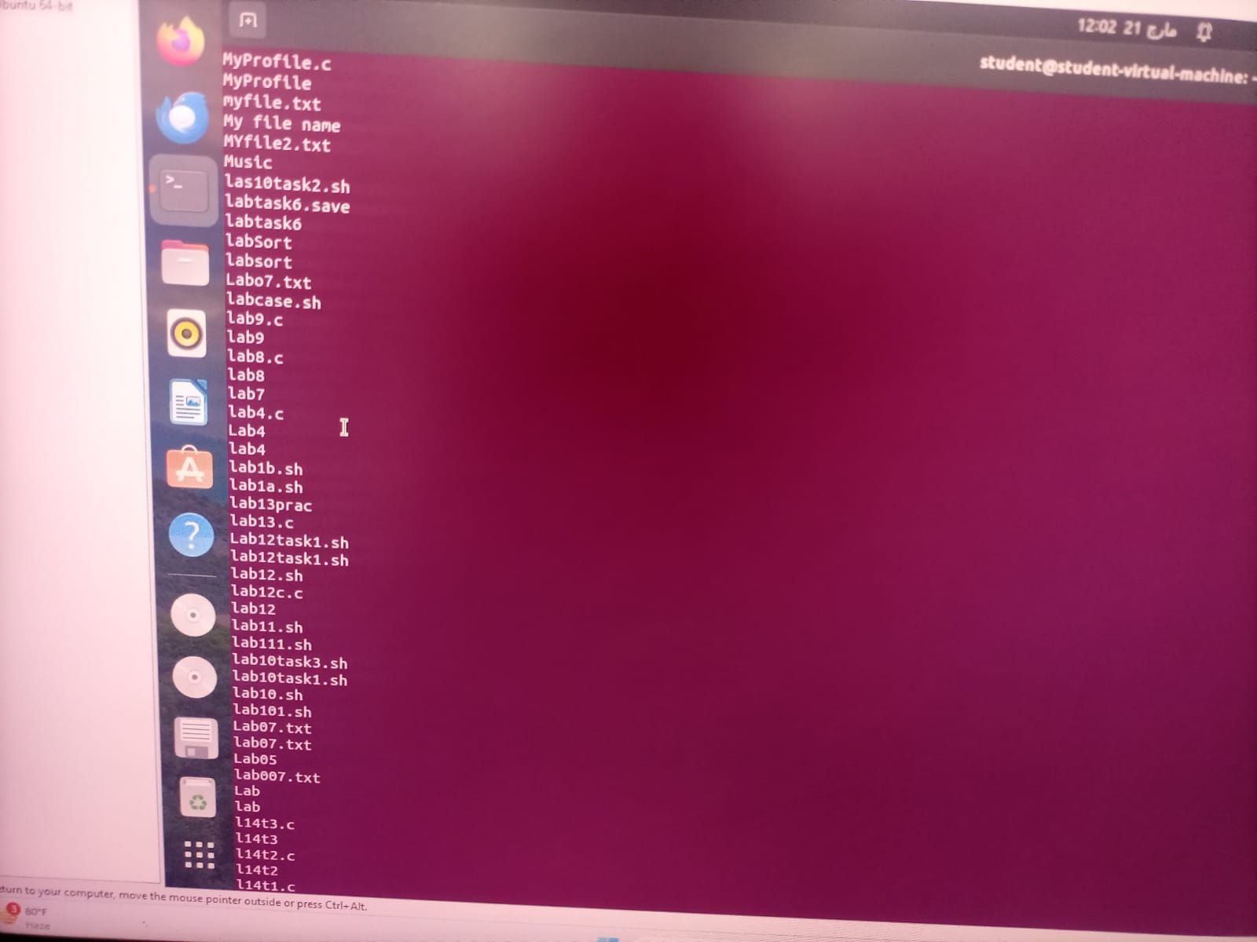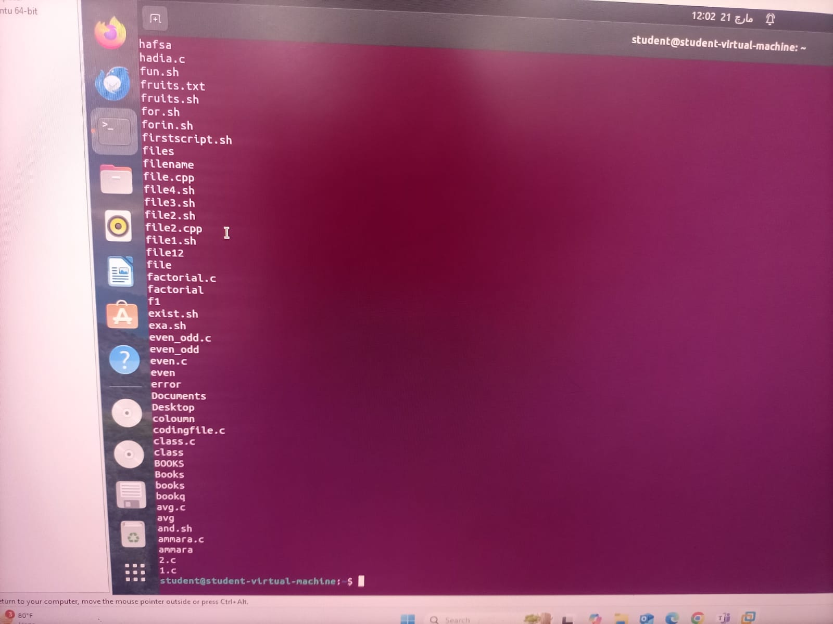

• **cat filename > new**

* This command reads the content of the file named filename and writes it into a new file called new.
* If new already exists, its content will be overwritten.
* Example: If filename contains "Hello World", after running this command, new will also contain "Hello World".

• **who > new**

* The who command displays the currently logged-in users.
* The output of who is redirected and saved into the file new.
* If new already exists, its content will be replaced.

• **ls | sort -r**

* The ls command lists files and directories in the current directory.
* The | (pipe) passes the output of ls to the sort -r command, which sorts the list in reverse (descending) order.
* This does not modify any file; it just displays the sorted result in the terminal.

• **ls | sort -r >> new**

* Similar to the previous command, ls | sort -r sorts the list of files and directories in reverse order.
* The >> operator appends this sorted output to the file new without erasing its existing content.
* If new does not exist, it will be created.

**Question 02**

**Write a command that does the following:**

1. Sorts the contents of **fruits.txt** in alphabetical order.
2. Filters the sorted output to only display fruits that contain the substring "ap".

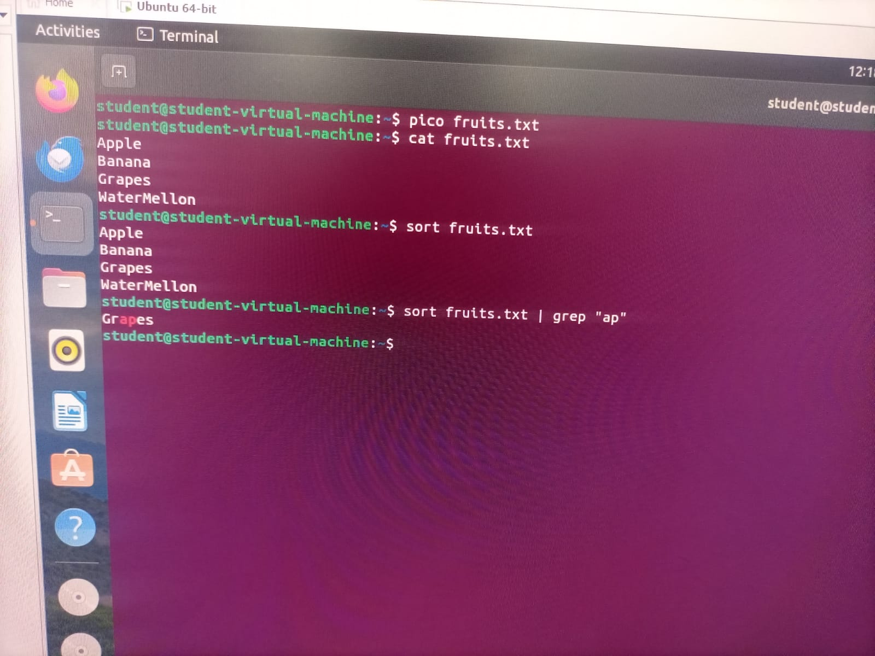

**Question 03**

Define streams, redirection and pipes with one example of each in your own words.

**Understanding Streams, Redirection, and Pipes in Linux**

**1. Streams**

Streams are channels used for input and output operations in a Linux system. There are three main types of streams:

* **Standard Input (stdin) (0):** Takes input from the keyboard or another source.
* **Standard Output (stdout) (1):** Displays output on the terminal.
* **Standard Error (stderr) (2):** Shows error messages.

**Example:**

echo "Hello, World!"

* **Here, "Hello, World!" is sent to stdout (the terminal).**

**2. Redirection (> and >>)**

Redirection is used to change the default input/output location of a command. It allows saving output into files instead of displaying it on the terminal.

**Example:**

ls > files.txt

* This command saves the list of files and directories into files.txt, overwriting its content if the file exists.

**3. Pipes (|)**

Pipes (|) allow the output of one command to be used as the input for another command. It helps in combining multiple commands efficiently.

**Example:**

ls | sort

* The ls command lists files, and its output is passed to sort, which sorts them alphabetically before displaying the result.